(HOSPITALITY AND TOURISM – INDUSTRY)

**1.Introduction:**

Preparing and maintained Zoho accounts for traveltrax tours is essential for efficient customer relationship management and overall business operation. Traveltrax tours involves setting up the system, customizing it to your needs, and consistently updating and optimizing it to support efficient customer relationship management and business growth.

**2.Purposes:**

* Traveltrax tours servers various purposes within the travel and tourism industry, catering to the needs and preference of travelers. Here are some of the key purposes for which travel trax tour operates:

1. Vacation planning
2. Custs mized tours
3. Group tours
4. Adventure and speciality tours
5. Crusie vacations
6. Educational and cultural experiences
7. Corporate travels services
8. Event planning
9. Travel logistics

* Zoho books is your one-stop platform for managing your accounting task organising your transaction. It is a single secure location to keepup with your companies bills and invoices, reconcile your bank statements control your spending, overseal projects, and eliminate GST compliance worries.

**3.Problem Definition & Design Thinking:**

**3.1.Empathy map:**

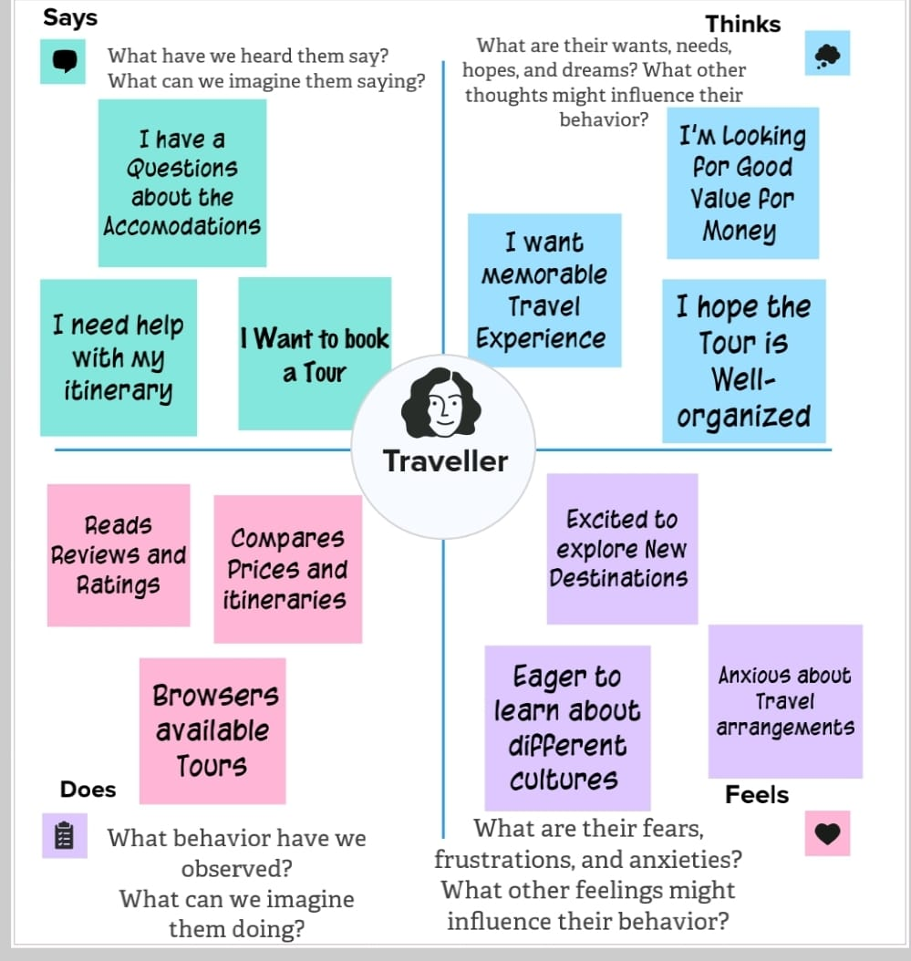

**3.2.Ideation & Brainstorm ideas:**

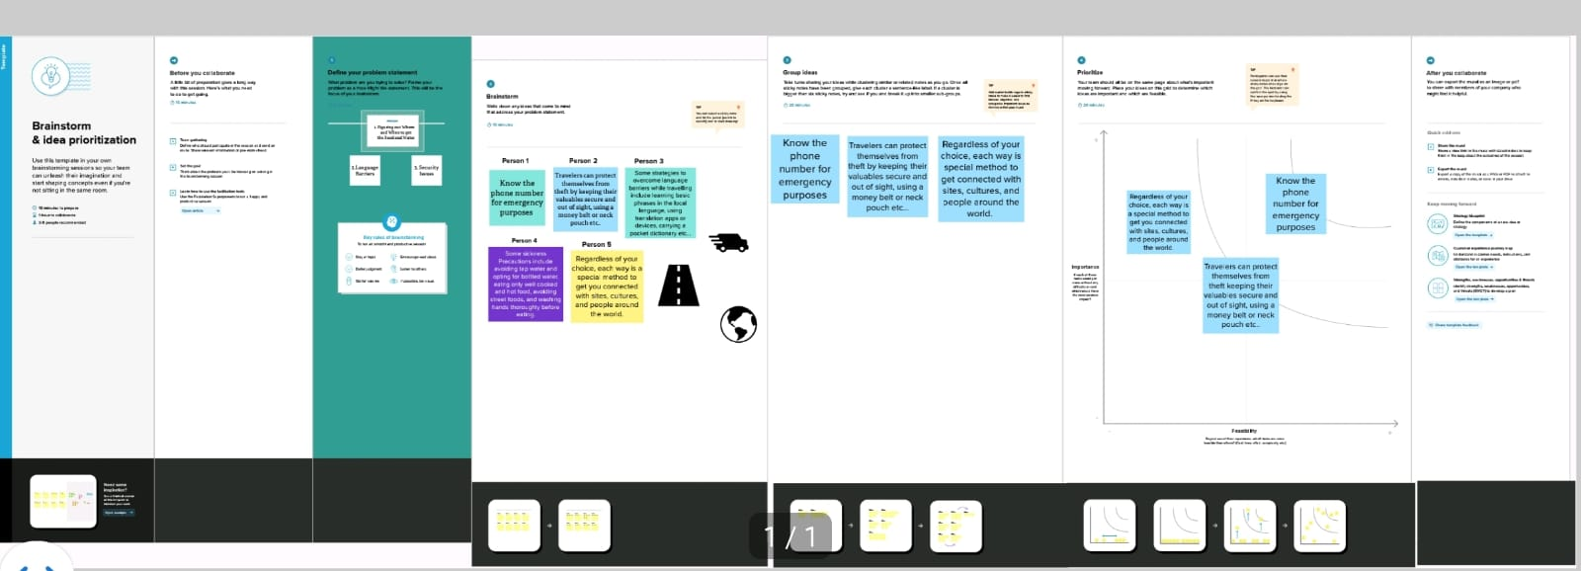

**4.Result:**

**Output:**

The output of profit and loss for Bhumiga Zoho company from 01/04/2023 to 31/03/2024 with the profit of Rs.26,95,000.00

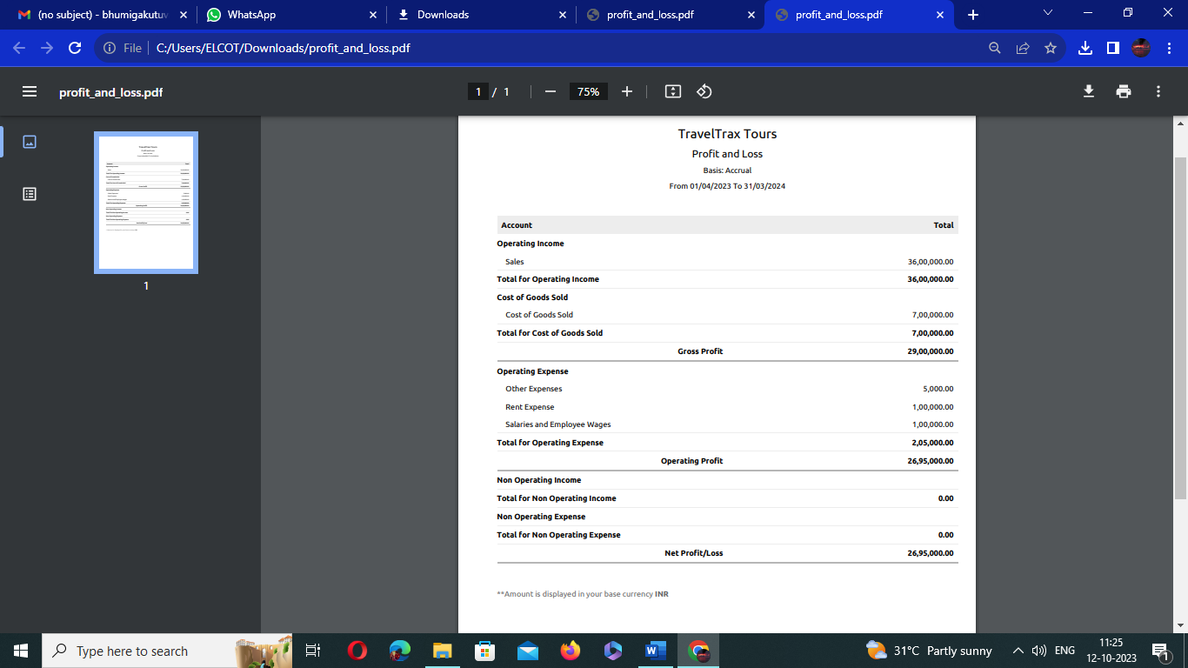

The balance sheet as on 31/3/2024 with the Total Assets and Total liabilities of Rs.35,43,000.00.

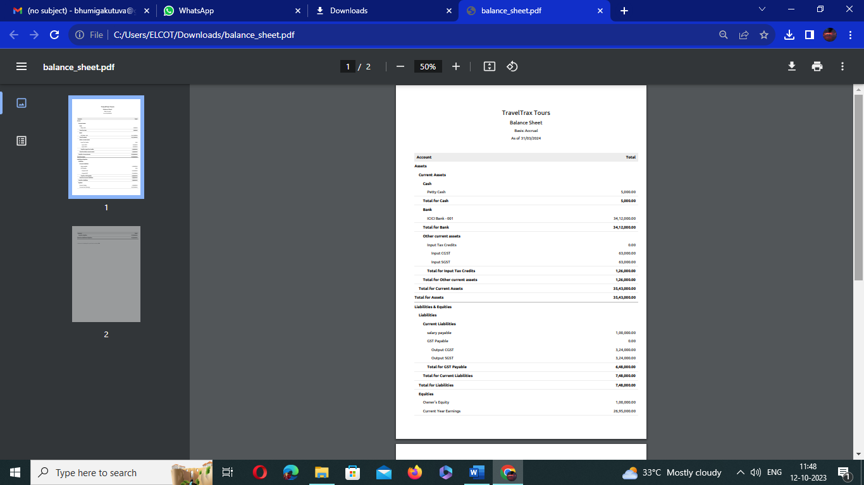

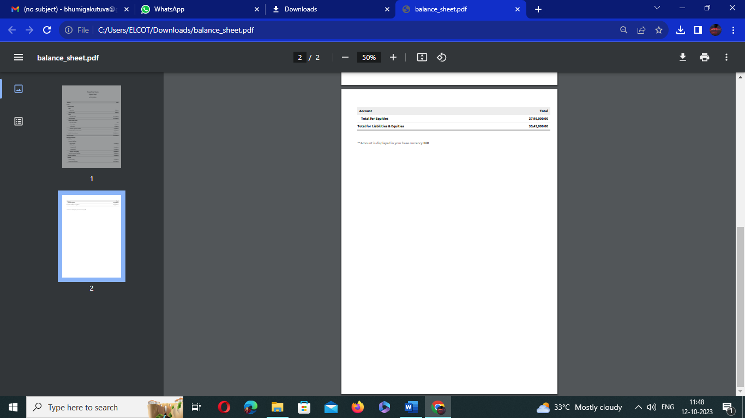

5.Applications:

* Zoho Expense comes with a comprehensive travel desk module that allows your travel team to manage business travel from start to finish.
* Here you can set agent assignment to autopilot for all travel requests and track them on priority basis.

6.Project description:

* Travel trax tours, a tour operator, leverages zoho books to manage their bookings, track expenses, and handle invoicing for their customers.
* They can generate professional invoices, reconcile payments, and monitor their financial performance.
* Zoho books helps them streamline their financial operations and enhance customer service.

7.Conclusion:

Preparation and Maintenance of zoho books for traveltrax tours for hospitality & tourism industry define the invoicing and payments. It also maintains the financial transparency with the profit and loss accounts and balance sheet.